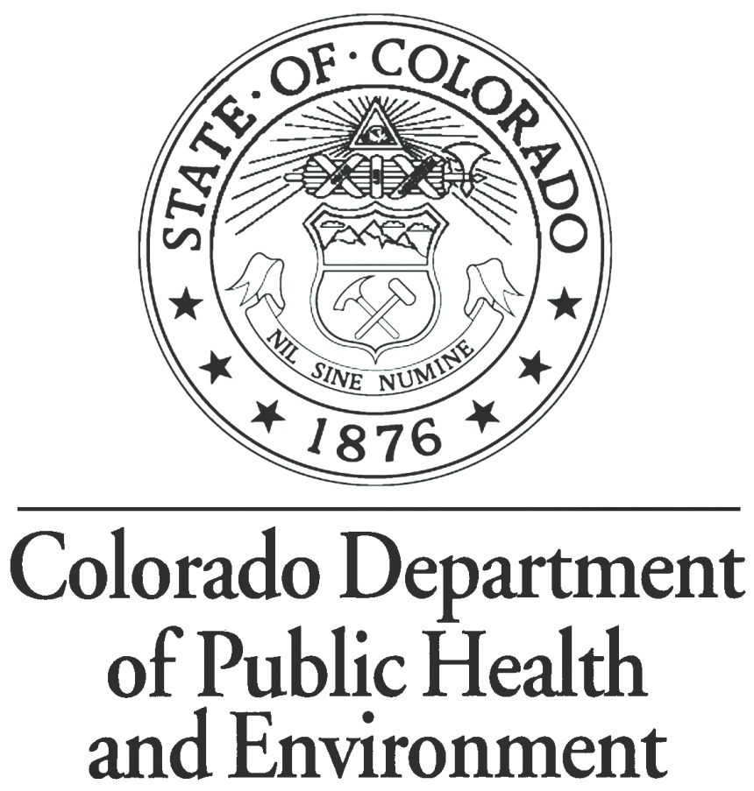
Hazard Definitions
Avalanche. The winter snow pack presents the danger of avalanche, particularly in the backcountry mountainous areas. They present a significant threat around many of the State's popular ski resort areas. The increasingly heavy usage of the backcountry during the winter months has heightened this ever present winter danger.

Blizzard. The propensity and likelihood of severe winter storms extends across the entire territory of the state. High winds, white out conditions, and massive snow accumulation are all components of severe winter storms and blizzards. Blizzards may impact power supplies, hinder transportation and the delivery of goods and supplies, or isolate communities.

Bomb Threat. Bomb threats are the attempt of an individual or organization to achieve a desired end-goal, which may or may not be stated, by threatening a target with the use of explosives. Bomb threats may be written, called in, or presented in person and may or may not actually involve a bomb. Though often bomb threats impact individual targets, thereby increasing the likelihood of assistance from the community, sometimes the threat may extend to a wider audience.

CBRNE. Stands for Chemical Biological Radiological Nuclear Explosive threats. These are generally identified as the five types of terrorist-based threats. However, each of these categories also has the potential to occur naturally or accidentally, and therefore should be included in mitigation, preparedness, response and recovery planning regardless of a community’s terrorist risk. Of particular note, ‘explosives’ in this section refers specifically to terrorist use. Therefore, a slightly different definition of ‘explosion’ is also included later in the hazard list.

Chemical. Colorado houses one of eight remaining U.S. Department of Army stockpiles of chemical weapons at the Pueblo Depot Activity (PUDA) in Pueblo, Colorado. Facilities in this area are subject to an increased risk from accidental exposure to nerve and blister agents stored at the arms depot, should the stockpiles become compromised in some way (such as an earthquake, fire, terrorist attack, or other disaster). Facilities located in this area (within a 30 mile radius of the depot) should partner with local emergency managers to develop appropriate sheltering or evacuation responses. Facilities located outside of this community are still at risk for accidental exposure to other chemical agents, which are generally addressed under the Hazardous Materials sections because they relate to more conventional (household) chemical exposures.

Biological. Contamination from sources of biological threats including anthrax, hantavirus, plague, influenza, ricin, and smallpox. Biological agents are divided into three categories (viral, bacterial, and toxins) which occur both naturally or in man-created situations for weaponization. Exposure to biological threats includes acts of terrorism, food and water contamination, animal sources, and person to person contact.

Radiological. Radiological sources include, but are not limited to, medical technologies and supplies, materials located at educational facilities, military resources, the manufacturing of products in certain factories, and everyday household objects such as smoke detectors, cell phones, computer screens and certain food processing techniques. Individuals are exposed to radiation every day. The danger comes from exposure to high doses, particularly in a very short amount of time or to large portions of the body. These potential exposures may include terrorist acts or other explosions that propel radioactive material into the air and onto the scene of a disaster.

Nuclear. Though similar to radiological threats, nuclear hazards specifically involve the elements of either plutonium or uranium. These events are often conceptualized as the catastrophic release of radioactive materials, generally due to explosion, either accidentally or intentionally. These thoughts often evoke impressions of a nuclear bomb, regardless of the actual source of nuclear hazard potential. These sources include research facilities, nuclear power plants, weapons assembly or storage plants, nuclear material storage facilities, and acts of terrorism.

Explosive. The weapon of choice for terrorism, explosive devices are relatively simple constructions of devices intended to explode and cause death, property damage and fear. Explosives are relatively inexpensive to assemble and potential materials are widely and easily available. Explosives may come in many sizes, may be detonated remotely or by a suicide bomber, and may be used to disperse other additional threats such as shrapnel or radiological agents.

Dam Failure. Dam failure is a technological threat facing many communities. In the last 100 years at least 130 of the more than 2,000 dams in the State have failed. The most recent major incident was the 1982 Lawn Lake disaster in Estes Park which caused more than $30 million in damages and the loss of three lives. There are 303 Class I (High Hazard) and 325 Class II (Moderate Hazard) dams located throughout the State, with the majority located along the Front Range and in the Grand Mesa areas. The failure of any of these dams has the potential of causing extensive property damage and possibly the loss of life. Many of these dams were constructed in the early 1900's making age a concern.

Drought. Even in high moisture years, Colorado rainfall does not provide a consistent, dependable water supply throughout the year. Severe drought results in devastating economic consequences for agriculture, forestry, wildlife management, the environment and tourism. Drought recorded history includes severe drought in 1894, 1930-1937, and 1976-1977. The drought of 2002-2005 caused loss of crops and livestock throughout much of the State and reduced revenues from lowered tourist visits. Drought is a concern for facilities because of potential water rationing, and because often drought occurs in concurrence with, or causes, other disasters such as extreme heat (which may result in the loss of power) and increased fire danger.

Earthquake. Colorado is rated in the United States Geologic Survey National Earthquake Hazard Maps as having low to moderate earthquake risk. However, several significant earthquakes have occurred within the State, including a magnitude 6.6 near Estes Park in 1882. Also, 90 potentially active faults have been identified to date, with potential, maximum credible earthquakes as high as M 7.5. HazardsUS (HAZUSMR) deterministic analyses of earthquakes on a number of these faults yield potential economic losses in the billions of dollars. Insufficient human and monetary resources have been allocated to an adequate study of the actual earthquake hazard in Colorado. Therefore, the Colorado Geological Survey recommends that site-specific earthquake studies be conducted for any proposed critical facility in the State.

Epidemic. Distinct from both an outbreak and a pandemic, an epidemic consists of the in-between levels of infection and transmission rates. Epidemics occur when a disease with a large capacity to affect the human population breaks out in a localized area that may be as large as a city, may affect cities independent of region, or may be sporadic in appearance but similar in timeframe on a world basis.

Explosion. Explosions may be caused by natural events or deliberately by human triggers. Explosions are aimed at property damage, loss of life, disruption of vital services, or to spread contaminants in a given area. Explosions may serve as primary or secondary disasters, and may target primary victims or secondary first responders.

Facility Fire. The greatest hazard facing individual facilities is that of a facility fire. Fires may occur because of a variety of natural or human-driven causes. Many inspections and current emergency planning for LTCFs revolves around the protection of the facility, and the residents who live there, from a facility fire.

Flooding. Flooding (flash and riverine) is the single greatest potential hazard to property in Colorado. Colorado averages 20+ floods each year. Riverine flooding, caused by rapid snowmelt, usually occurs in May and June. The Western Slope region often experiences riverine flooding in fall months of September and October due to seasonal heavy thunderstorm activities. Flash flooding, usually caused by heavy, stationary thunderstorms, most often occurs in the spring and early summer months (the fall months for southwestern Colorado). Damage potential is greatest along the river basins in the inter-mountain areas and the floodplains along the Front Range. Areas in and below land burned by wildfire have an increased risk of flooding.

Food/Supply Shortage. Generally a secondary hazard, food and supply shortages compromise the ability of a facility or community to remain in place. It may be caused by the loss of transportation routes, hampered supply lines impacted by severe weather, or poor pre-planning.

Hazardous Materials. Hazardous materials used in agriculture, industry, and in the home pose a daily hazard to people and the environment. Coloradoans are vulnerable to the adverse effects of accidental leakage of hazardous materials or a deliberate act using these materials. During the 2002-2005 period, the Department of Public Health and Environment recorded 2,431 reported spills or releases; 993 were at fixed facilities. There are approximately 5,800 fixed facilities where reportable concentrations of hazardous materials are used and/or stored. The oil and gas production industry accounts for 4,200 of those facilities.6 The steady growth in the use of chemicals has resulted in an increased need to transport these materials. Hazardous materials are transported over nearly every roadway throughout the State.

Infectious Disease Outbreak. Generally through lack of hygiene, infectious diseases such as flu, meningitis, E. coli, salmonella or staph can break out in a community or facility. Mitigation prevents most of these outbreaks and includes good personal hygiene, hand washing with soap or antibacterial gels, cough etiquette, the use of personal protective equipment (PPE), and good housekeeping. Outbreaks are not the same as epidemics or pandemics, but may incur similar effects within a single facility.

Landslide. Landslides may occur by themselves or in conjunction with another natural event such as wildfire, severe winter snowmelt, or heavy rains. In recent years, losses from landslides and debris flows have been extremely high in areas already devastated by wildfires.

Missing Resident. A missing resident hazard occurs when a facility is unable to locate a resident under their care, particularly when that resident may pose a danger to themselves or other people. Residents may go missing independent of other hazards, or the situation may be a direct outcome of a hazard. In identifying procedures to locate the resident, primary care of other members of the facility must be maintained.

Pandemic. According to the Center for Disease Control (CDC), a pandemic is a global disease outbreak, for which there is little or no immunity in the human population, that begins to cause serious illness and then spreads easily person-to-person worldwide. It is most commonly associated with influenza. Influenza pandemics come in waves lasting between two and three months, with each outbreak of the wave lasting between six and eight weeks in the impacted community. Pandemics are not surprises, and many mitigation factors can help decrease the severity of the pandemic’s impact on a given community.

Severe Weather. Winter storms in Colorado are occasionally severe enough to overwhelm snow removal efforts, transportation, utilities, livestock management, and business and commercial activities. All of Colorado is vulnerable to storms of disaster proportions. Urban areas, especially those along the Front Range with large populations, are more vulnerable because of larger, more complex, and interdependent services and utilities.

Staff Shortage. Generally the result of another disaster in the community, a staff shortage leaves a facility or community unable to respond to basic daily needs with adequate people. Risks include improper or sub-par care for residents or patients, lack of access to trained medical personnel, overexertion of remaining employees, redistribution of workloads and responsibilities, or employee burnout and attrition.

Subsidence. This is the sudden sinking or gradual downward settling of land with little to no horizontal motion. It is caused by the loss of support systems underground. Causes of these support losses are both natural and manmade, and include subsurface mining, pumping oil and groundwater, or other activities that allow the land below the surface to erode. Depending on where they occur, subsidence hazards may pose significant threats to a community by disrupting transportation, destabilizing construction, or compromising gas, electric and water lines.

Terrorism. Colorado is at risk for terrorism (domestic and international) and national security incidents. These incidents could take the form of threats and hoaxes, chemical, biological, radiological, nuclear, small-scale conventional weapons or explosives, large improvised explosives, or cyber attacks.

Tornados. Tornados are a common threat to those who live along the Front Range and on the Eastern plains of Colorado but tornados have occurred in nearly all counties of the State. The effect of damaging tornados is increasing as more people and businesses are locating in threatened areas. April through October is considered the tornado season, with May and June as the greatest risk months.

Transportation Emergency. Particularly in areas with high traffic of vehicles carrying hazardous materials, the potential for a transportation-based emergency may influence planning. This includes railcars, tankers, large trucks, or airways. Road quality, weather conditions, other hazards or terrorism are all potential impacts on the transportation industry.

Utility Disruption/Loss of Vital Services. The interruption or loss of electricity, gas or water to a facility or community for a period of time that compromises the integrity of the location, threatens human life safety and health, or interferes with vital services are all concerns of utility disruption. This hazard may occur as a secondary effect of another hazard, or as the result of construction, accident, or terrorism.

Wildfires. Wildfire, both natural and human-caused, is a risk to which the entire State is susceptible. The Colorado State Forest Service (CSFS) estimates approximately 1/4th of the State’s current population resides within the Red Zone, an area characterized by over six million acres of forestland at high risk for large-scale wildland fire. A century of aggressive fire suppression, combined with cycles of drought and changing land management practices, has left many of Colorado’s forests unnaturally dense and ready to burn. In 2002, there were more than 3,072 wildfires that burned more than 915,000 acres.

Colorado State EOP, p 14.
Colorado State EOP, p 15.
Colorado State EOP, p 14.
Colorado State EOP, p 14.
Colorado State EOP, p. 13
Colorado State EOP, p 15.
Colorado State EOP, p 14.
Colorado State EOP, p 14.
Colorado EOP, p 15.
Colorado State EOP, p. 13
Colorado State EOP, p. 13

