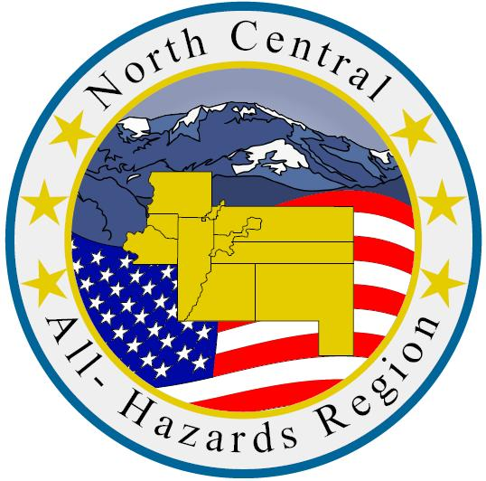

**North Central Region**

**Adult-Care Facility**

**Table Top Exercise**

**Tool-kit**

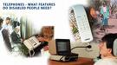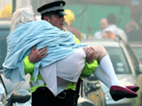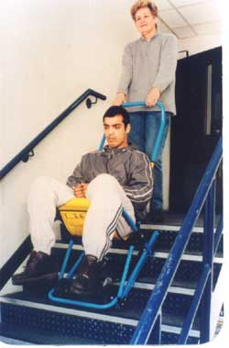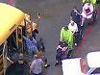

Contingency Planning

***Senior Care***

Emergency

Response

Recovery

